Drag and drop

**Part 1**

1 First of all: To make an element draggable, set the draggable attribute to true:

<img **draggable="true"**>

<img id="drag1" src="unitecLogo.jpg" **draggable="true"** **ondragstart="drag(event)"** width="200" height="169">

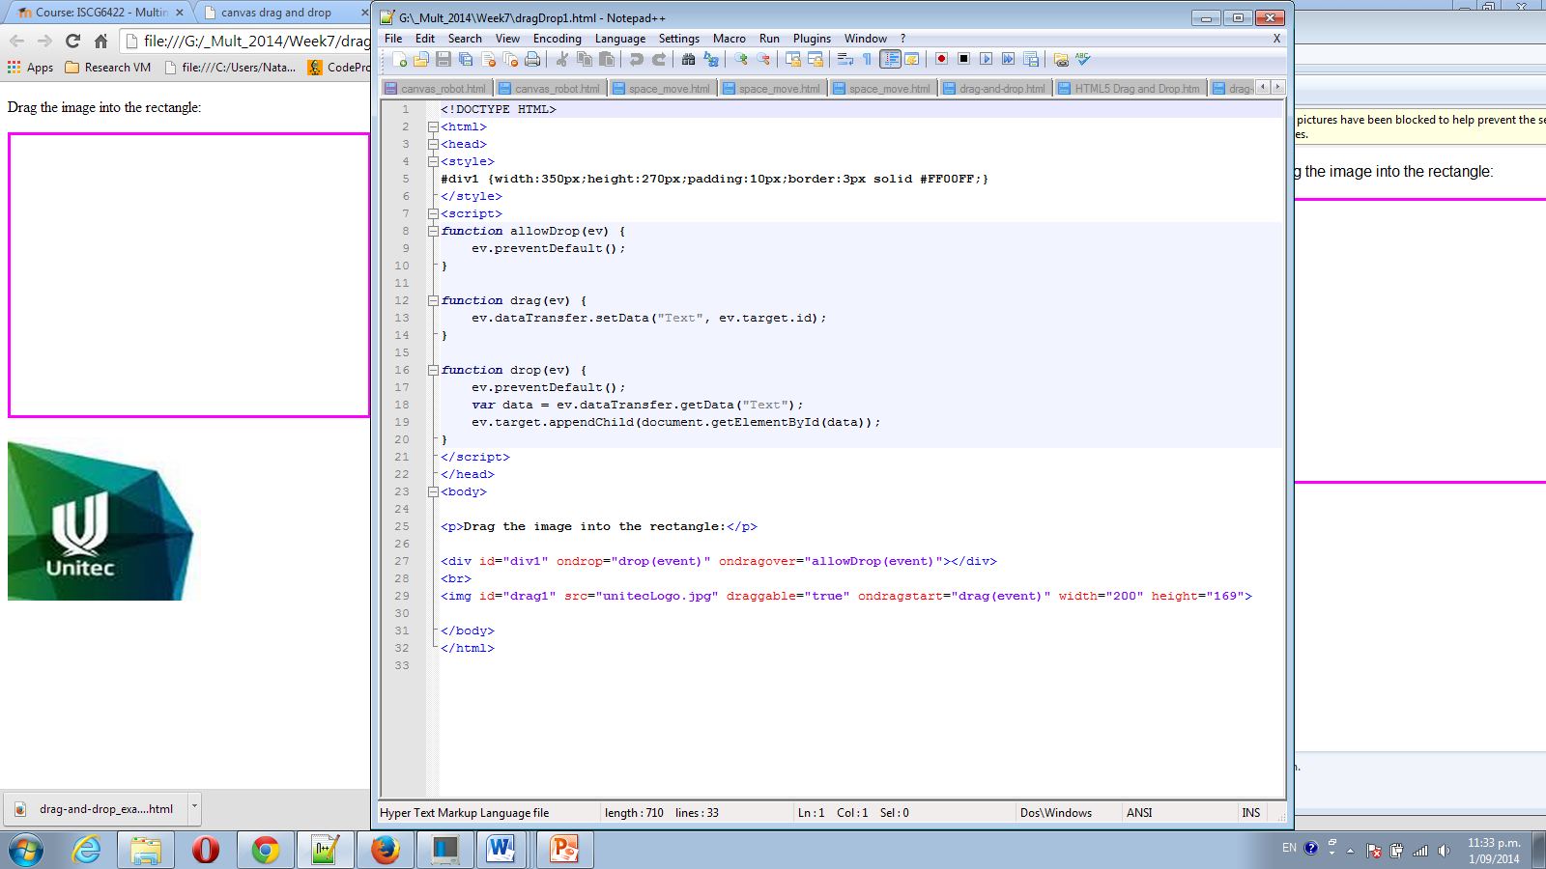

2 in the area where we want to drop:

<div id="div1" **ondrop="drop(event)" ondragover="allowDrop(event)"**></div>

3 write functions:

**allowDrop(ev)**

**drag(ev)**

**drop(ev)**

4 Modify a code to add one more “box” – div. and make some text “drag-able” as well

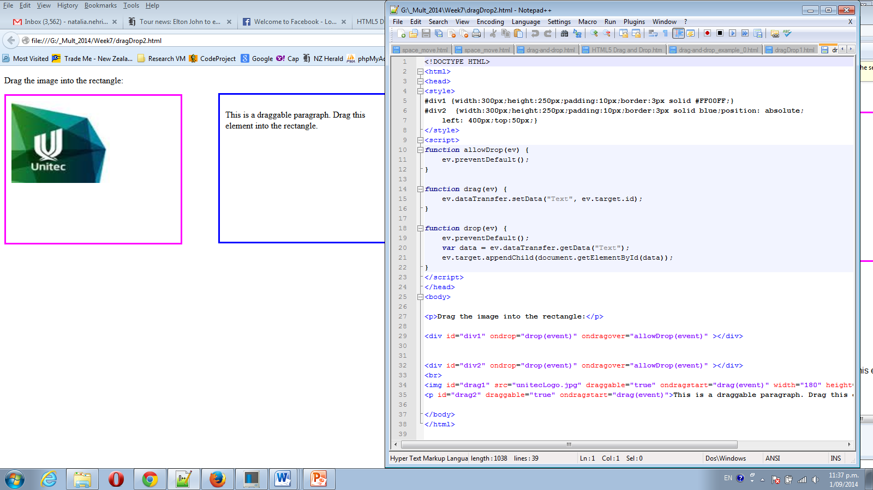

Next add messages on enter box:

**<div id="divMsg1">I appear on enter </div>**

**<div id="divMsg2">I appear on drop </div>**

Please define style for them, in style section:

**#divMsg1, #divMsg2 { color:red; visibility:hidden; }**

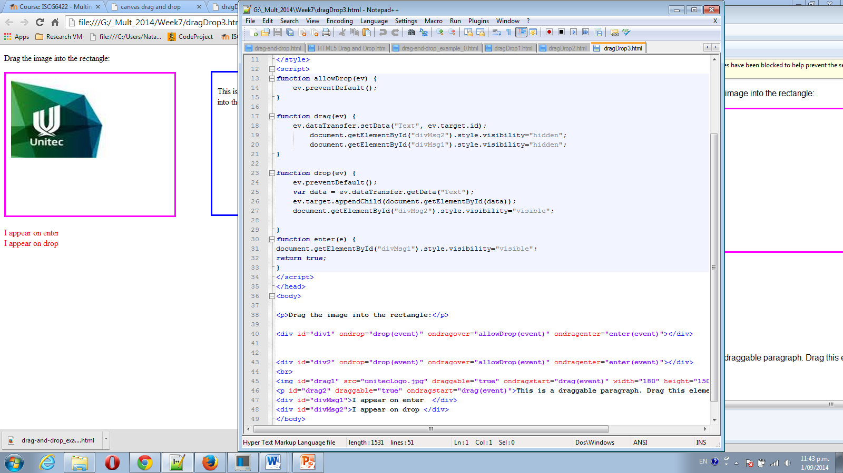

Modify your function, that these messages become visible one on enter and other on drop.

**Part 2**

Using files from folder **HTML5 Drag and Drop_files**

1 Review how **Shopping example work , file is** HTML5 Drag and Drop.htm

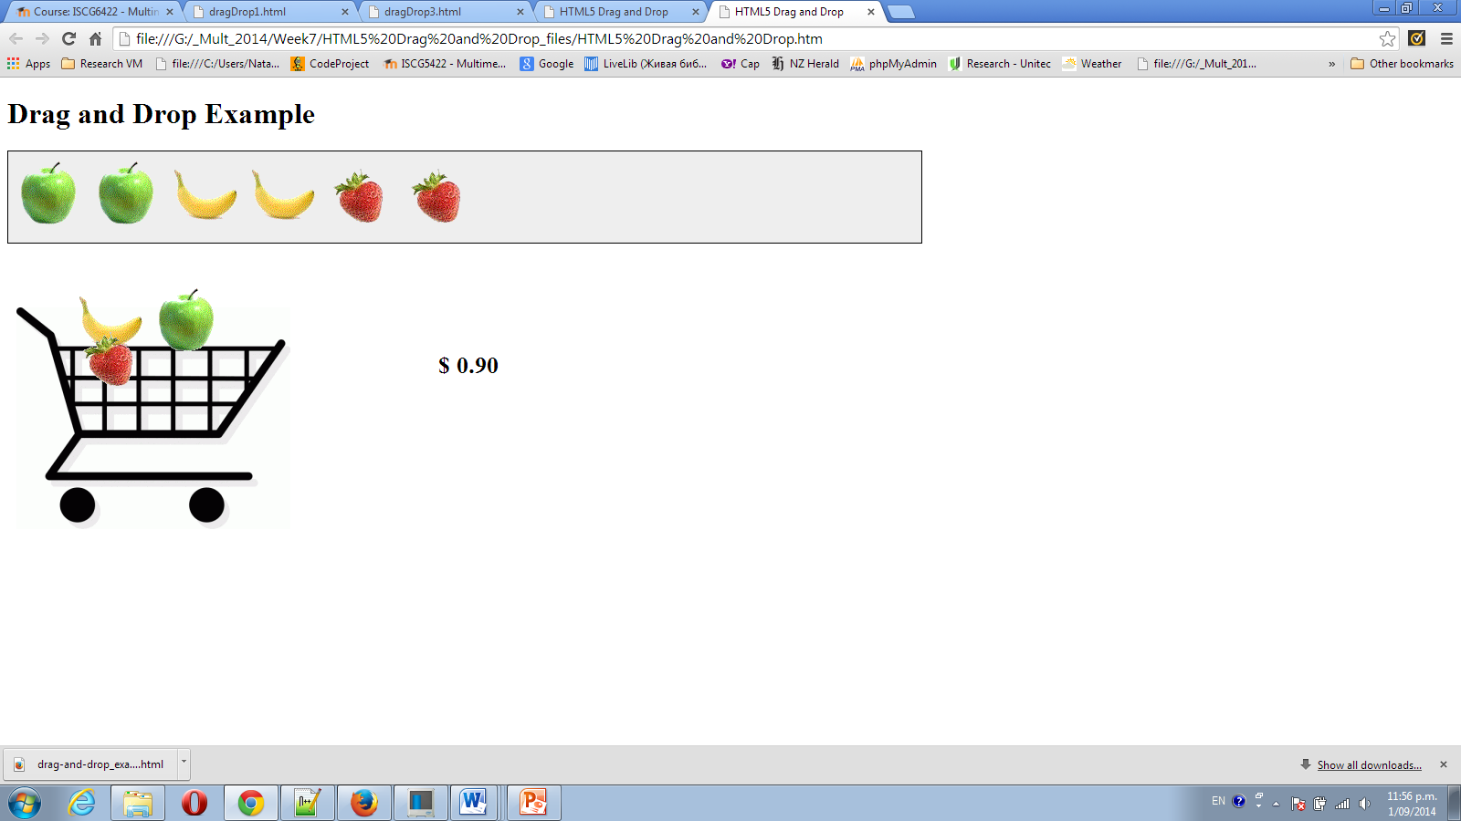

2 Using file drag-and-drop_example_0.html as a start point please make images of fruits movable. It should be possible to drop them to yellow and green boxes.

3 Modify function that apples can go to green box only and bananas to yellow box only. Display message on wrong drop.

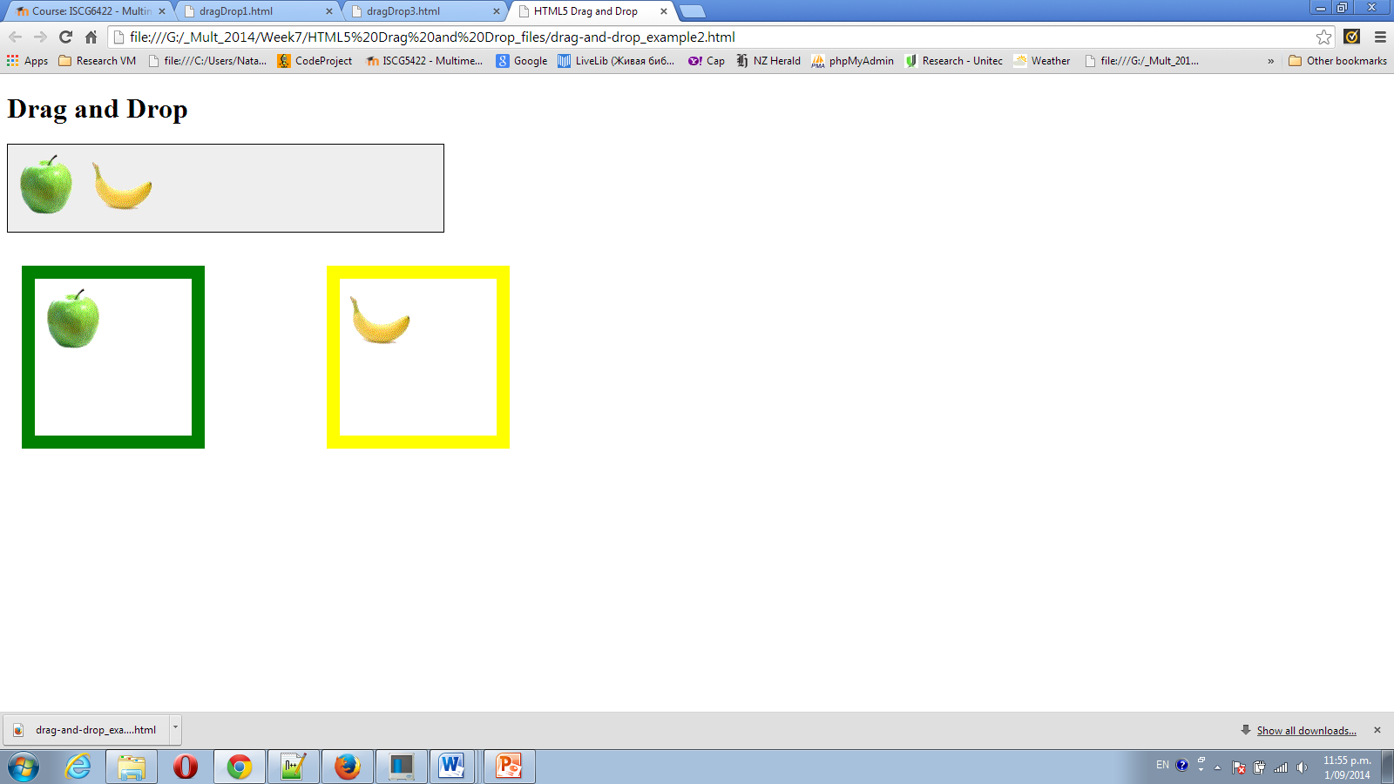

**Part 3**

**Canvas Drag and Drop**

